Top-Level Use Case Diagram (System Overview)
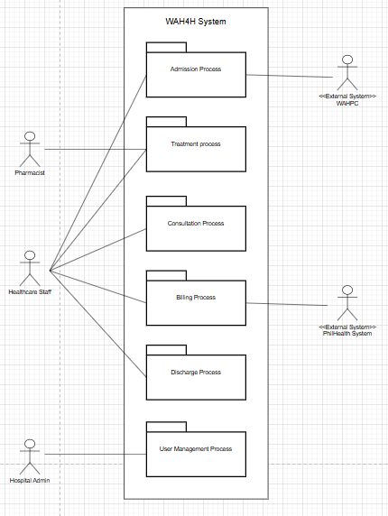
Figure 1: Top-Level Use Case Diagram
Description:
The top-level use case diagram shown in Figure 1 presents the major modules (packages) of the WAH4H HIMS and their interaction with system actors.

Low-Level Use Case Diagrams (per Package)

2.1 Admission Progress
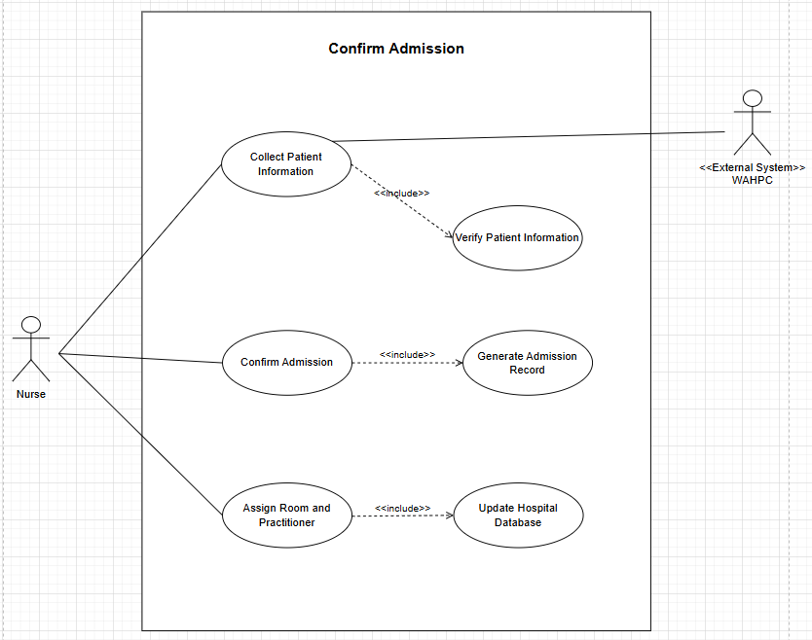
Figure 2: Low-Level Use Case Diagram Admission Process Package
Description:
The Admission Process Package: manages the registration and onboarding of patients into the hospital system. It handles the creation of admission records, room or ward assignment, and verification of doctor availability. It ensures that patients are officially recorded in the hospital database before receiving any medical services.

2.2 Treatment Process Package
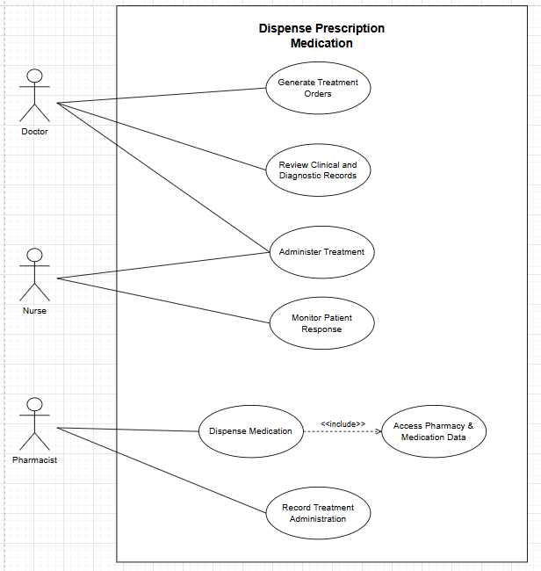
Figure 3: Low-Level Treatment Process Use Case Diagram
Description:
The Treatment Process Package: outlines the end-to-end treatment workflow for a patient, including the creation, delivery, and evaluation of therapeutic interventions, along with documentation of progress and modifications in the health record. It represents the core phase of clinical care that follows diagnosis and focuses on delivering and refining medical treatment.

2.3 Consultation Process Package
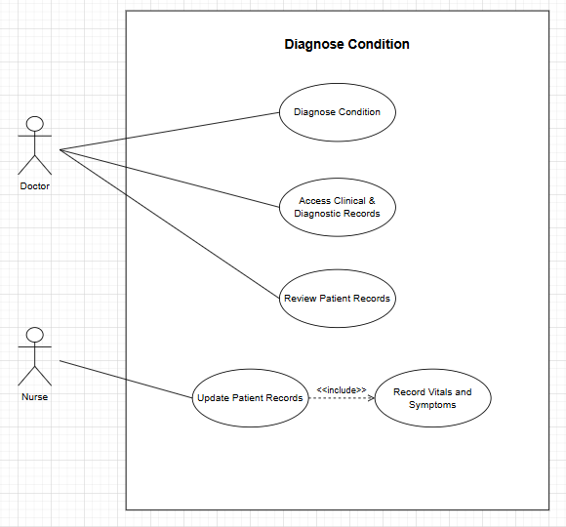
Figure 4: Low-Level Consultation Process Use Case Diagram
Description:
The Consultation Process Package covers the patient’s medical consultation workflow, from scheduling and conducting consultations to updating the patient’s health record with findings and recommendations. It serves as the initial step before treatment and diagnostic procedures.

2.4 Billing ProcessPackage
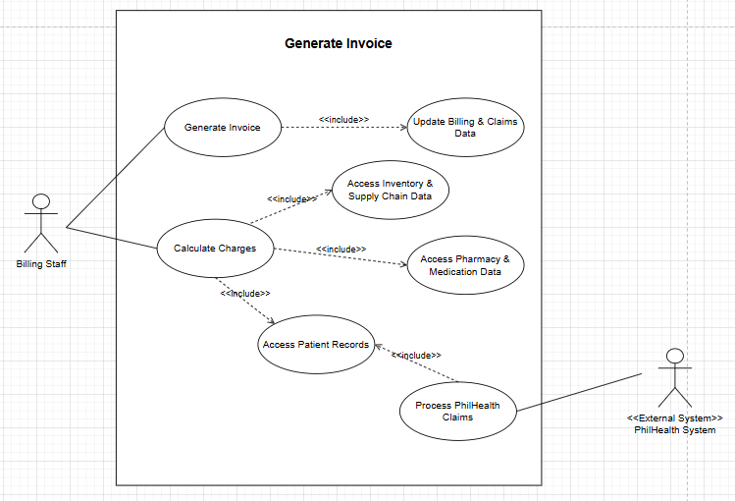
Figure 5: Low-Level Billing Process Use Case Diagram
Description:
The Billing Process Package manages financial transactions associated with patient services. It calculates charges for treatments, laboratory services, and medications. The package also handles payment processing and insurance claims to ensure accurate and transparent billing records.

2.5 Discharge Process Package
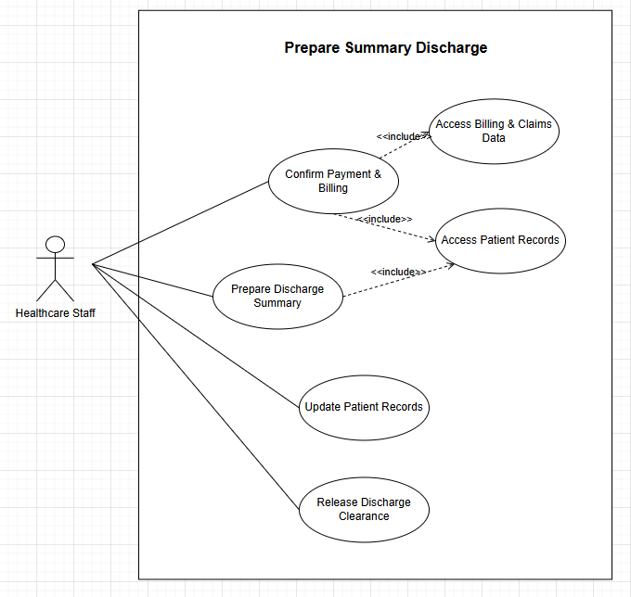
Figure 6: Low-Level Discharge Process Use Case Diagram
Description:
This package oversees the completion of a patient’s hospital stay. It ensures that all medical services are completed, billing is settled, and the discharge is officially approved. The process also includes generating discharge summaries and updating the patient’s medical record for closure.

2.6 Users Management Package
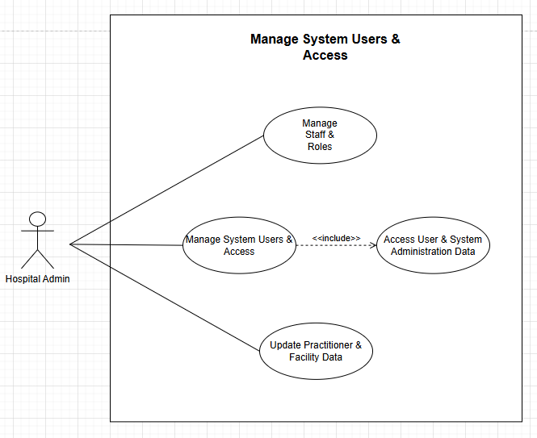
Figure 7: Low-Level Users Management Use Case Diagram
Description:
The Users Management Package handles the creation, modification, and removal of user accounts within the HIMS. It defines user roles and access permissions for doctors, nurses, billing staff, pharmacists, and administrators to maintain system security and accountability.

Use Case Full Description:
Package: Admission Process
Use Case Name: Confirm Admission
Use Case ID: | UC-01
Author | Jhon Lloyd R. Nicolas
Purpose | To verify and confirm a patient’s admission into the hospital system by validating personal information, room availability, and assigned practitioner details.
Requirement Traceability | BR-01
Priority | High
Preconditions | - Patient information has been provided and verified.  - Room and practitioner availability data exist in the system.
Postconditions | - Patient admission record is confirmed and stored in the database.  - Assigned room and practitioner are marked as “Occupied” or “Assigned.”
Actors | Nurse
Extends | Includes → Generate Admission Report
Flow of Actions | Basic Flow  - Actor selects Confirm Admission.  - System displays verified patient details.  - Actor assigns room and practitioner.  - System validates selections.  - Actor confirms admission.  - System updates patient status and records admission  Alternative Flows:  - Room not available → system prompts to select another.  - Practitioner unavailable → system requests reassignment.  - Missing patient info → system prompts to complete data.  - System error → action logged; actor notified.

Package: Treatment Process
Use Case Name: Submit Lab Request
Use Case ID: | UC-02
Author | Mariyah Vanna Monique Chavez
Purpose | To allow the nurse to administer prescribed treatments or medications to admitted patients and record the completion and relevant notes in the system.
Requirement Traceability | BR-02
Priority | High
Preconditions | - Patient must be admitted and have an active treatment order.  - Nurse must be logged in with authorized access rights.  - Required medication or treatment materials must be available
Postconditions | - Treatment administration is recorded in the system.  - Patient record and treatment log are updated.  - Medication inventory (if applicable) is adjusted.
Actors | Nurse
Extends
Flow of Actions | Basic Flow  - Nurse views assigned patients and pending treatments.  - Nurse selects a treatment to administer.  - System displays treatment details.  - Nurse confirms administration.  - System records treatment and updates patient record.  Alternative Flows  - Treatment already completed → system notifies nurse.  - Medication unavailable → system marks as pending.  - System error → action logged; nurse notified.

Package: Consultation Process
Use Case Name: Diagnose Condition
Use Case ID: | UC-03
Author | Elijah Josh R. Quibin
Purpose | To enable the doctor to assess the patient’s condition, record findings, and determine a diagnosis based on consultation and test results.
Requirement Traceability | BR-03
Priority | High
Preconditions | - Patient has an active consultation record.  - Doctor is logged in with valid credentials.  - Relevant lab or test results (if any) are available.
Postconditions | - Diagnosis details are recorded in the patient’s health record.  - System updates the patient’s consultation status.
Actors | Doctor
Extends
Flow of Actions | Basic Flow  - Doctor accesses the patient’s consultation record.  - System displays patient details and recent medical results.  - Doctor enters observations and diagnosis.  - System saves the diagnosis and updates patient record.  Alternative Flows  - Missing test results → system prompts for completion or request.  - Invalid input → system rejects and prompts correction.  - System error → action not saved; doctor notified.

Package: Billing Process
Use Case Name: Generate Invoice
Use Case ID: | UC-04
Author | Elijah Josh R. Quibin
Purpose | To generate an invoice for a patient’s hospital services and charges.
Requirement Traceability | BR-04
Priority | High
Preconditions | - Patient record and billing details exist in the system.  - Actor must be logged in as Billing Staff.
Postconditions | - Invoice is generated and available for printing or download.  - If unsuccessful, the actor is notified.
Actors | Billing Staff
Extends
Flow of Actions | Basic Flow  - Billing Staff selects Generate Invoice.  - System prompts to select patient.  - Actor selects patient and confirms.  - System retrieves billing data.  - Invoice is generated and displayed/exported.  Alternative Flows  - Patient not found → system notifies actor.  - No billing data → system cannot generate invoice.  - System error → error logged, actor notified.

Package: Discharge Process
Use Case Name: Prepare Summary Discharge
Use Case ID: | UC-05
Author | Mariyah Vanna Monique C. Chavez
Purpose | To enable the attending nurse or doctor to prepare and finalize a patient’s summary discharge, including the patient’s treatment details, diagnosis, medications, and follow-up instructions before discharge approval.
Requirement Traceability | BR-05
Priority | High
Preconditions | - Patient has completed all medical treatments and evaluations.  - All billing and clearance processes are finalized.  - Actor must be logged in with appropriate medical staff access rights.
Postconditions
  - Patient discharge summary is generated and stored in the system.
  - Patient record status is updated to “Discharged.”
  - Summary is made available for patient and administrative viewing.
Actors | Healthcare Staff
Extends
Flow of Actions | Basic Flow  - Actor selects Prepare Summary Discharge  - System displays patient’s admission and treatment records.  - Actor reviews details and inputs final diagnosis, medications, and recommendations.  - Actor confirms and submits discharge summary.  - System generates and saves summary discharge report.  Alternative Flows  - Incomplete patient record → system prompts actor to review pending details.  - Billing not cleared → system notifies actor to wait for settlement.  - System error → action logged and actor notified.

Package: User Management
Use Case Name: Manage System Users & Access
Use Case ID: | UC-06
Author | Mariyah Vanna Monique C. Chavez
Purpose
  To enable the Hospital Administrator to create, update, deactivate, and assign specific roles or permissions to hospital staff, ensuring secure access control and proper role-based functionality within the Hospital Information Management System (HIMS).
Requirement Traceability | BR-06
Priority | High
Preconditions | - Actor must be logged in as a Hospital Administrator.  - The system’s user database must be active and accessible.  - Role definitions and access privileges must exist in the system.
Postconditions | - Staff accounts are successfully created, updated, or deactivated.  - Roles and permissions are properly assigned or modified.  - Audit logs are generated for accountability.
Actors | Hospital Admin
Extends
Flow of Actions | Basic Flow  - Administrator selects Manage Staff & Roles.  2. System displays the current staff list with roles and statuses.  3. Administrator chooses to create, update, or deactivate a staff account.  4. Administrator fills in details or updates role assignments.  5. System validates input and saves changes.  6. System confirms successful operation and records the action in the audit log.  Alternative Flows  - Invalid input → system rejects and prompts correction.  - Unauthorized action → access denied.  - System error → error logged, actor notified.

Test Case Table
TC ID | UC ID | Test Case Name | Test Case Description
TC-01 | UC-01 | Confirm Admission | Ensure the nurse can verify and confirm a patient’s admission by validating personal details, assigning a room, and linking a practitioner before storing records.
TC-02 | UC-02 | Submit Lab Request | Verify that the nurse can submit and record a laboratory or treatment request for an admitted patient, and the system updates the patient’s record accordingly.
TC-03 | UC-03 | Diagnose Condition | Confirm that the doctor can assess and record the patient’s diagnosis during consultation, and the system saves the findings accurately in the health record.
TC-04 | UC-04 | Generate Invoice | Ensure that billing staff can generate, view, and export accurate invoices for hospital services provided to a patient.
TC-05 | UC-05 | Submit PhilHealth Claim | Validate that billing staff can successfully submit a PhilHealth claim for insurance reimbursement and receive system confirmation.
TC-06 | UC-06 | Manage Accounts | Ensure that the hospital administrator can create, update, or deactivate user accounts, and assign system roles securely and correctly.

RTM (Requirements Traceability Matrix)

Business Rqt No | Use Case ID | Test Case ID
BR-01 | UC-01 | UC-01 → TC-01
BR-01 | UC-01 | UC-01 → TC-02
BR-01 | UC-01 | UC-01 → TC-03
BR-01 | UC-01 | UC-01 → TC-04
BR-01 | UC-01 | UC-01 → TC-05
BR-01 | UC-01 | UC-01 → TC-06
BR-01 | UC-01 | UC-01 → TC-07
BR-01 | UC-01 | UC-01 → TC-08
BR-01 | UC-01 | UC-01 → TC-09
BR-01 | UC-01 | UC-01 → TC-10
BR-02 | UC-02 | UC-02 → TC-01
BR-02 | UC-02 | UC-02 → TC-02
BR-02 | UC-02 | UC-02 → TC-03
BR-02 | UC-02 | UC-02 → TC-04
BR-02 | UC-02 | UC-02 → TC-05
BR-02 | UC-02 | UC-02 → TC-06
BR-02 | UC-02 | UC-02 → TC-07
BR-02 | UC-02 | UC-02 → TC-08
BR-02 | UC-02 | UC-02 → TC-09
BR-02 | UC-02 | UC-02 → TC-10
BR-03 | UC-03 | UC-03 → TC-01
BR-03 | UC-03 | UC-03 → TC-02
BR-03 | UC-03 | UC-03 → TC-03
BR-03 | UC-03 | UC-03 → TC-04
BR-03 | UC-03 | UC-03 → TC-05
BR-03 | UC-03 | UC-03 → TC-06
BR-03 | UC-03 | UC-03 → TC-07
BR-03 | UC-03 | UC-03 → TC-08
BR-03 | UC-03 | UC-03 → TC-09
BR-03 | UC-03 | UC-03 → TC-10
BR-04 | UC-04 | UC-04 → TC-01
BR-04 | UC-04 | UC-04 → TC-02
BR-04 | UC-04 | UC-04 → TC-03
BR-04 | UC-04 | UC-04 → TC-04
BR-04 | UC-04 | UC-04 → TC-05
BR-04 | UC-04 | UC-04 → TC-06
BR-04 | UC-04 | UC-04 → TC-07
BR-04 | UC-04 | UC-04 → TC-08
BR-04 | UC-04 | UC-04 → TC-09
BR-04 | UC-04 | UC-04 → TC-10
BR-05 | UC-05 | UC-05 → TC-01
BR-05 | UC-05 | UC-05 → TC-02
BR-05 | UC-05 | UC-05 → TC-03
BR-05 | UC-05 | UC-05 → TC-04
BR-05 | UC-05 | UC-05 → TC-05
BR-05 | UC-05 | UC-05 → TC-06
BR-05 | UC-05 | UC-05 → TC-07
BR-05 | UC-05 | UC-05 → TC-08
BR-05 | UC-05 | UC-05 → TC-09
BR-05 | UC-05 | UC-05 → TC-10
BR-06 | UC-06 | UC-06 → TC-01
BR-06 | UC-06 | UC-06 → TC-02
BR-06 | UC-06 | UC-06 → TC-03
BR-06 | UC-06 | UC-06 → TC-04
BR-06 | UC-06 | UC-06 → TC-05
BR-06 | UC-06 | UC-06 → TC-06
BR-06 | UC-06 | UC-06 → TC-07
BR-06 | UC-06 | UC-06 → TC-08
BR-06 | UC-06 | UC-06 → TC-09
BR-06 | UC-06 | UC-06 → TC-10

